.
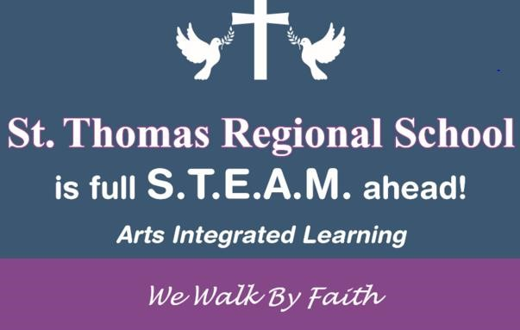
May

2022
Sun. Mon. Tue. Wed. Thu. Fri. Sat.
1 | 2 | 3 | 4 | 5 | 6 | 7  First Communion
8  Happy  Mother’s Day | 9 | 10 | 11 | 12 | 13  Crowning of Mary Mass  8:45  Ladies’ Choice Dance | 14
15 | 16 | 17 | 18 | 19 | 20 | 21
 |  |  |  |  | Gentlemen’s Choice Dance
22 | 23 | 24 | 25 | 26 | 27  No School Professional Day | 28
29 | 30  No School Memorial Day | 31 | May 25th Lunch orders for June due by May 25th  Last Day of School

