.
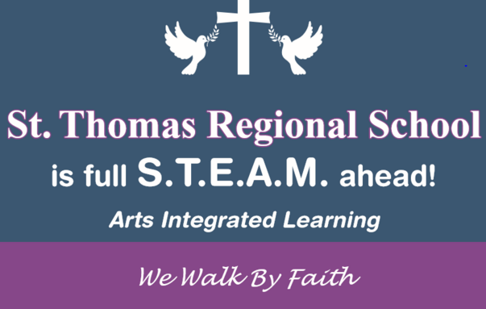 | October  2019
Sun. | Mon. | Tue. | Wed. | Thu. | Fri. | Sat.
1 | 2 | 1 | 2 | 3 | 4 | 5
 |  |  | Jaswell’s Farm  PreK, K, 1 |  | Upper School Field Trip Boston
6 | 7 | 8 | 9 | 10 | 11 | 12
 |  |  |  | Flu Clinic  8am – 10am  Cafeteria | Mass 8:45  RI Reds  Progress Reports Go Home
13 | 14 | 15 | 16 | 17 | 18 | 19
 | No School  Columbus Day | Winter Uniforms Begin
20 | 21 | 22 | 23 | 24 | 25 | 26
Trunk or Treat
6pm – 8pm
27 | 28 | 29 | 30 | 31
 | Lunch Orders for November Due | Confreda Farm  Prek, k, 1

