.
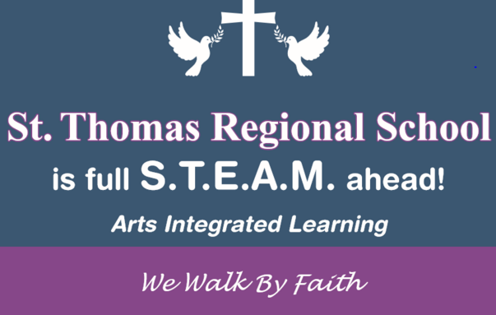 | December 2019
Sun. | Mon. | Tue. | Wed. | Thu. | Fri. | Sat.
 |  |  |  |  |  | 1
 |  | Happy  New Year! | Welcome Back!
2 | 3 | 4 | 5 | 6 | 7 | 8
 |  |  |  | RI Reds  Parent Luncheon  11am | Epiphany Mass  Anchors  8:45 am
9 | 10 | 11 | 12 | 13 | 14 | 15
 |  |  | Progress Reports Go Home
16 | 17 | 18 | 19 | 20 | 21 | 22
23 | 24 | 25 | 26 | 27 | 28 | 29
Open House  11am - 1pm |  | Catholic | Schools’  “Let’s Go To The Movies”  Lincoln Cinema | Week | Mass 8:45  Parent Classroom Visitation
30 | 31

