.
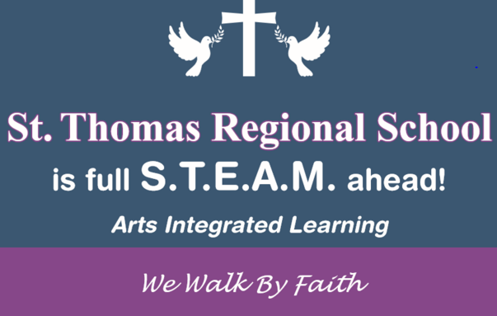 | February 2019
Sun. | Mon. | Tue. | Wed. | Thu. | Fri. | Sat.
 |  |  |  |  | 1 | 2
Catholic School Week
Mass - 8:45am
Parent Classroom Visition

3 | 4 | 5 | 6 | 7 | 8 | 9
 | Tall Ships  Benediction  12:30 pm |  |  | Quahogs  Parent Luncheon  11:45am-1:15pm
10 | 11 | 12 | 13 | 14 | 15 | 16
Valentine’s Day
Wear Red

RI Reds
Chapel Mass
12:30 pm

17 | 18 | 19 | 20 | 21 | 22 | 23
24 | 25 | 26 | 27 | 28 | March 129 | 2
Mother/Son Dance
7 pm

3 | 4

